A PRELIMINARY PROJECT REPORT
ON
GROUP EXPENSE TRACKER
SPONSORED BY
QED42 COMPANY
BY
LOPAMUDRA CHAKRABORTY
SNEHAL KADAM
RENUKA DESHMUKH
NEHA WALTURE

GUIDE
PROF. RAJASHREE KULKARNI

CUMMINS COLLEGE OF ENGINEERING
FOR WOMEN
KARVENAGAR, PUNE-411052

CERTIFICATE

This is to certify that the following students
- Lopamudra Chakraborty
- Snehal Kadam
- Renuka Deshmukh
- Neha Walture
Have completed the preliminary work for the project entitled “Group Expense Tracker” satisfactorily for the partial fulfillment of the requirement of the Bachelor’s Degree in Computer Engineering of Pune University during the academic year 2010-2011.

Internal Examiner External Examiner

Prof. Mrs. Rajashree Kulkarni

Mrs. Shubhangi V. Tikhe Dr. Mrs. Madhuri B. Khambete
Head of the Department Principal
Cummins College of Engineering Cummins College of Engineering

ACKNOWLEDGEMENT

We would like to thank our guide, Professor Mrs. Rajashree Kulkarni for providing valuable inputs and throughout the preparation phase of the report. We would also like to thank our external guide Mr. Dipen Choudhary for giving us the opportunity to do this project, helping us to understand the topic and giving us valuable guideline.

Lopamudra Chakraborty
Renuka Deshmukh
Snehal Kadam
Neha Walture

ABSTRACT

We often go on trips and movies with friends, we end up paying for each other at different points of our trips and usually end up doing mental calculations of who paid what and then sharing the expense. There are few web applications that lets room-mates, friends track personal finances and share expenses they made over time, but we make most of the expenses when we are outside on the go and we dont have a laptop or solid internet connection to update the expenses made. This Android app caters to those people who are outside when they make those expenses, the app does not rely on internet connection to log expenses while offline but will sync the expenses online when we are in presence of internet connection. We feel that this app is very useful to manage these small personal finance issues and keep everyone in the loop.

We plan to use Android platform to develop these apps, android is gaining market share
since its release in 2008 and is not tied to a handset. Android is completely open source and developed by Open handset alliance led by Google, we are already seeing smartphones in
the range of 10-15k INR using android in Indian market and we feel that it will only be more
cheaper from here on in comparison to Apple Iphone which is another popular smartphone but
costs upward of 30k INR. Hence we feel over the time android users will increase in India and
elsewhere and would be a good platform to build this application.

We will use ruby on rails web framework to manage transactions and expenses online in a
central location which would be a minimal web service to which android connects and updates the expenses. In the first version we are focused on getting the mobile app out with minimal web service support for android on rails and subsequently we might as well build a dashboard for users on the webservice to manage expenses via web.

This app will be a utility app which has widespread use cases and will benefit lot of people to manage personal finances not just on the trip with friends but their personal expenses.

INDEX

- List of Tables………………………………………………………………………….7
- List of Figures………………………………………………………………………...7

- Literature Survey………………………………………………………………………...8
  - Problem Statement……………………………………………………………………8
  - Objective……………………………………………………………………………...8
  - History/Background………………………………………………………….……….8
  - Android……………………………………………………………………………….8
    - Features………………………………………………………………………..9
    - Android Architecture………………………………………………………….9
    - Applications…………………………………………………………………..10
    - Strengths of Android OS……………………………………………………..11
    - Weaknesses of Android OS…………………………………………………..11
  - Motivation…………………………………………………………………………...11
  - Comparison of Approaches………………………………………………………….12
    - SQLite vs. MySQL…………………………………………………………...12
    - Ruby on Rails vs. ASP.NET…………………………………………………14
    - Ruby on Rails vs. MS Access………………………………………………..15
  - Description of Proposed System…………………………………………………….16
  - Strengths and Weaknesses…………………………………………………………..17
    - Strengths……………………………………………………………………..17
    - Weaknesses…………………………………………………………………..17

- Software Requirement Specification…………………………………………………..18
  - Introduction………………………………………………………………………….18
    - Purpose of this document…………………………………………………….18
    - Definitions, Acronyms and Abbreviations…………………………………...18
  - General Description…………………………………………………………………20
    - User Personas and Characteristics……………………………………………21
    - Overview of Functional Requirements……………………………………….21
    - Overview of Data Requirements……………………………………………..21
  - Operating Enviornment………………………………………………………22
    - Software Requirements………………………………………………………22
    - Hardware Requirements……………………………………………………...22
  - General Constraints, Assumptions, Dependencies, Guidelines……………………..22
  - Specific Requirements………………………………………………………………23
    - External Interface Requirements……………………………………………..23
    - Detailed Description of Functional Requirements…………………………...23
    - Detailed Description of Functional Requirements…………………………...24
  - Performance Requirements………………………………………………………….27
  - Quality Attributes……………………………………………………………………27

- High Level Designs……………………………………………………………………...28
  - Entity Relationship Diagram………………………………………………………...28
  - Use-Case Diagram…………………………………………………………………..29
  - Class Diagram……………………………………………………………………….30
  - Activity Diagram…………………………………………………………………….31
  - Deployment Diagram………………………………………………………………..32

- Conclusion……………………………………………………………………………….33

Appendix: References………………………………………………………………………34

List of Tables:
2.1 Definitions, Acronyms and Abbreviations…………………………………………...18

List of Figures:
  - Android Architecture…………………………………………………………………10
  - Entity Relationship Diagram…………………………………………………………28
  - Use-Case Diagram……………………………………………………………………29
  - Class Diagram………………………………………………………………………..30
  - Activity Diagram……………………………………………………………………..31
  - Deployment Diagram………………………………………………………………...32

CHAPTER 1: LITERATURE SURVEY

  - Problem Statement
An Android based mobile application for Group Expense Tracker. In this application, user will track the expenses on the android phone. The user creates groups and tracks all his expenses incurred. In this application he can create groups with his own phone contacts and also Facebook contacts. As Internet is not always available at our disposable, if such a mobile application exists it will be of enumerable help at any given time of the day which will help him/her to analyze and track his budget and save on expenses.

  - Objective
Expenses Tracker is a simple and friendly expenses tracking application focused on helping you manage your expenses.

  - History/Background
The group expense tracker manages all your financial accounts in one convenient place and makes your money management much easier and handy. Our expense tracking software lets you compare your spending with other friends who share similar group circles so you can see how much they typically spend and identify the best ways to save on your money. With expense tracker you can not only view your investments at each stage but also can send notifications to Facebook friends at the time of group creation and logging expenses. Our application is new concept very easy and simple to handle, not very complicated as other mobile applications. The main benefit of using mobile phone is that it’s simple and innovative.

  - Android
Android is a software stack for mobile devices that includes an operating system, middleware and key applications. The Android SDK provides the tools and APIs necessary to begin developing applications on the Android platform using the Java programming language.
1.4.1 Features
- Application framework enabling reuse and replacement of components
- Dalvik virtual machine optimized for mobile devices
- Integrated browser based on the open source WebKit engine
- Optimized graphics powered by a custom 2D graphics library; 3D graphics based on the OpenGL ES 1.0 specification (hardware acceleration optional)
- SQLite for structured data storage
- Media support for common audio, video, and still image formats (MPEG4, H.264, MP3, AAC, AMR, JPG, PNG, GIF.
- GSM Telephony (hardware dependent)
- Bluetooth, EDGE, 3G, and Wi-Fi (hardware dependent)
- Camera, GPS, compass, and accelerometer (hardware dependent)
- Rich development environment including a device emulator, tools for debugging, memory and performance profiling, and a plug-in for the Eclipse IDE

1.4.2 Android Architecture
The following diagram shows the major components of the Android operating system. Each section is described in more detail below:

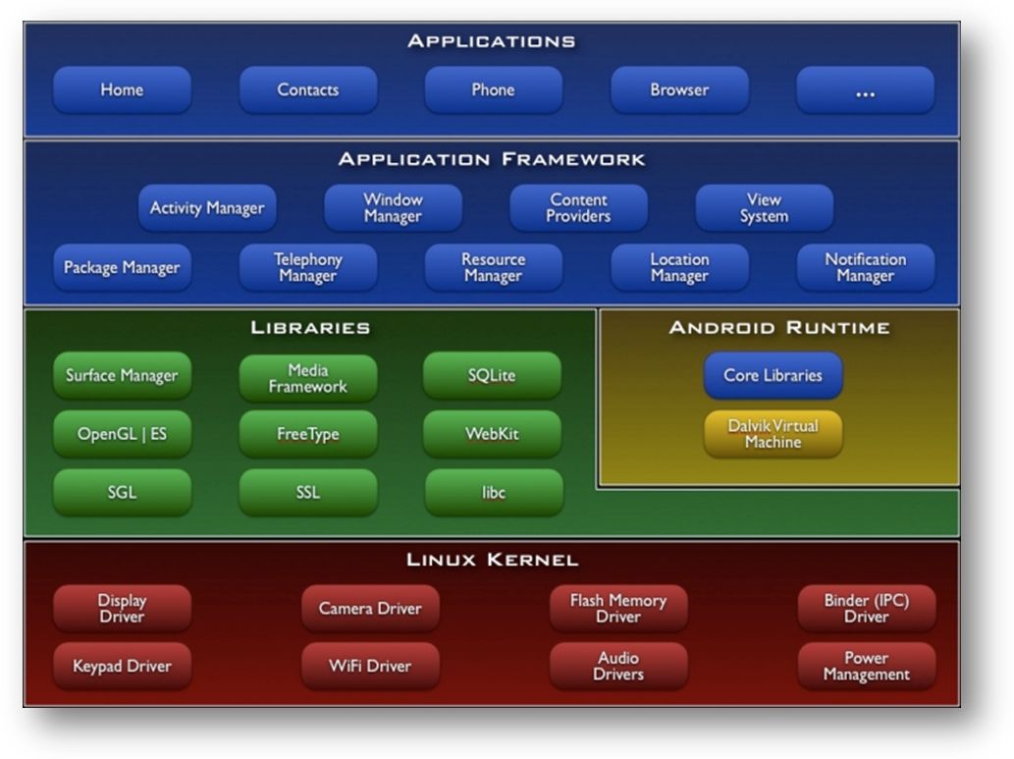
Fig. 1.1: Android Architecture

1.4.3 Applications
Android will ship with a set of core applications including an email client, SMS program, calendar, maps, browser, contacts and others. All applications are written using the Java programming language.

By providing an open development platform, Android offers developers the ability to build extremely rich and innovative applications. Developers are free to take advantage of the device hardware, access location information, run background services, set alarms, add notifications to the status bar and much, much more.

Developers have full access to the same framework APIs used by the core applications. The application architecture is designed to simplify the reuse of components; any application can publish its capabilities and any other application may then make use of those capabilities (subject to security constraints enforced by the framework). This same mechanism allows components to be replaced by the user.

1.4.4 Strengths of Android OS
- Totally open API
- Device and network-independent software platform
- Android app marketplace is democratic (unlike Apple's)
- OS is updated often! even for older devices like the HTC Dream (T-Mobile G1)
- True multi-tasking OS based on Linux kernel
- Mostly free third-party apps
- Has great potential to scale well up to higher-end devices like Smartbooks (various laptop manufacturers experimenting with this)

1.4.5 Weaknesses of Android OS
- Fewer developers and a smaller user base than the more established iPhone / iOS software ecosystem
- User lacks the ability to definitively close applications from within task manager
- Few payment options for application marketplace - only Google Checkout
- No review process on the application marketplace, nothing stopping malware from getting published
- no multi-touch implementations on handsets sold in the U.S. (up to at least Android v2.1)
- Limited to Google accounts

  - Motivation
There exist quite a few web-based software called as expense trackers. Some of them are stand alone applications which provide a single service like tracking personal expenses where as others provide a combination of services. However, there does not exist, any software which is essentially for a group expense tracking. The motivation behind taking up such a problem statement was the fact that Internet is not always available at our disposable. If such a mobile application exists it will be of enumerable help at any given time of the day.
Group expense tracker includes maintaining expenses, clearing dues, adding new member if not on phonebook list and Facebook list, creating events, sending notifications and other tasks – ideally all coordinated and executed on mobile. The expense tracker keeps you informed about who spend how much and who owns how much to the other. It tracks each ones expenses with ease.
Above all, Group expense tracker helps you cut down on the total amount of time it takes to investigate problems. There exists quite a few expense tracker applications but nothing like our applications as it provides integration with Facebook, which is unique.

  - Comparison of Approaches
1.6.1 SQLite vs. MySQL
SQLite is an Open Source library that implements a self-contained transactional SQL database engine which requires no server and works on little or no configuration. MySQL on the other hand is also an Open Source Relational Database Management System.
Diving right into the task of answering this question, we have provided an itemized list of some the things SQLite is capable of doing well and we have compared the same with MySQL.

SQLite is:
- easy to set up, and in many cases no configuration or installation is necessary
- great enough to use for databases you would only need on a temporary basis or for test purposes
- not suitable where user management is needed as SQLite uses the file systems permissions so there is no way you will be able to use SQL statements such as GRANT and REVOKE.
- suitable for using in embedded applications and installations and embedding into applications themselves
- great for rapid development
- lacking in performance measurement features
- not suitable where concurrency transactions on the databases is required
- suitable for using on small to medium website. These are websites with average 100K or less hits per day.
- suitable in replacement of Ad-hoc file storage commonly where applications access files using fopen(), fread() and fwrite().

MySQL is:
- far more difficult to set up and configuration of users is a must
- good for creating temporary databases as well as for test purposes. This would only be practical if you have the MySQL database server and client already set up
- not suitable for embedding in some hardware as you would still need the server component of the database. MySQL though is suitable for embedding into application using provided libmysql libraries
- great for rapid development in some situations
- perfect for concurrency transactions on the data and is well suited for multi-user environment
- great for large scale production applications which scale even over clustered database configurations
- suitable for use on small, medium and large scale websites taking in billions of hits a day
- highly scalable as far as the MySQL data and tables go and can be manipulated any time the MySQL DBA. This scaling capabilities transcends disks, physical servers and location
- not intended to replace fopen(), fread() and fwrite(). MySQL manages its own data files and not the operating system
- fully compatible with stored procedures, triggers, view and other operations common with other major Relational Database Management Systems. MySQL only provides these features with selected storage engines.
1.6.2 Ruby on Rails vs. ASP.NET
Basically, ASP.NET is a compiled, managed framework for building web applications on top of the .NET Framework.
Rails are a framework upon which developers can build web applications written using the Ruby programming language (scripting language carries a somewhat negative connotation, so I prefer to refer to Ruby as a programming language). Ruby is a very powerful object-oriented, interpreted programming language that incorporates a lot of extremely good ideas from SmallTalk and other "pure functional" programming languages (such as the ability to utilize lambda expressions, treat code as data, etc). Rails is a framework for creating web applications with Ruby. RoR enforces the Model-View-Controller pattern in an absolutely rigid fashion. RoR has a very "Web 2.0"-ish feel to it. It feels very progressive, forward thinking and it lends itself extremely well to an iterative, Extreme Programming (XP) type of life cycle where you produce small bits of testable functionality and then continue outward in a spiral from there - adding more and more and refactoring as you go if need be. RoR includes out of the box support for multiple data environments (e.g. test, development, production, etc), as well as support for building unit tests for the entire site. RoR's philosophy is all about convention over configuration. If you agree to a couple of rules that are really not much more than some commonly agreed upon best practices, then things will magically "just work" and you can override the convention with configuration if you feel that you must.

ASP.NET uses the .NET Framework to provide a framework upon which developers can build web applications. It doesn't enforce any particular pattern on you, and I've often found that in the hands of the untrained, ASP.NET can produce some of the most hideous, difficult to read, difficult to maintain, difficult to troubleshoot code known to man. Conversely, in the hands of a "tersity purist", Ruby can be pretty damn cryptic as well.

Rather than enforce the use of a Model-View-Controller, ASP.NET 2.0 gives you the magic of "code-behind" ASPx pages.

1.6.3 SQLite vs. MS access
MS Access:
Users can create tables, queries, forms and reports, and connect them together with macros. Advanced users can use VBA to write rich solutions with advanced data manipulation and user control.

The original concept of Access was for end users to be able to "access" data from any source. Other uses include: the import and export of data to many formats including Excel, Outlook, ASCII, dBase, Paradox, FoxPro, SQL Server, Oracle, ODBC, etc. It also has the ability to link to data in its existing location and use it for viewing, querying, editing and reporting. This allows the existing data to change and the Access platform to always use the latest data. It can perform heterogeneous joins between data sets stored across different platforms. Access is often used by people downloading data from enterprise level databases for manipulation, analysis, and reporting locally.

There is also the Jet Database format (MDB or ACCDB in Access 2007) which can contain the application and data in one file. This makes it very convenient to distribute the entire application to another user, who can run it in disconnected environments.

One of the benefits of Access from a programmer's perspective is its relative compatibility with SQL (Structured Query Language) — queries can be viewed graphically or edited as SQL statements, and SQL statements can be used directly in Macros and VBA Modules to manipulate Access tables. Users can mix and use both VBA and "Macros" for programming forms and logic and offers object-oriented possibilities. VBA can also be included in queries.

SQLite:
SQLite implements most of the SQL-92 standard for SQL but it lacks some features. For example, it has partial support for triggers, and it cannot write to view. While it supports complex queries, it still has limited ALTER TABLE support, as it cannot modify or delete columns.
SQLite uses an unusual type system for an SQL-compatible DBMS. Instead of assigning a type to a column as in most SQL database systems, types are assigned to individual values; in language terms it is dynamically typed. Moreover, it is weakly typed in some of the same ways that Perl is: one can insert a string into an integer column (although SQLite will try to convert the string to an integer first, if the columns’ preferred type is integer). This adds flexibility to columns, especially when bound to a dynamically typed scripting language. However, the technique is not portable to other SQL databases. The inability to have the domain integrity coming from statically typed columns, as in typical databases, is a common criticism. The SQLite web site describes a "strict affinity" mode, but this feature has not yet been added. However, it can be implemented with constraints likeCHECK(typeof(x)='integer').

Several computer processes or threads may access the same database without problems. Several read accesses can be satisfied in parallel. A write access can only be satisfied if no other accesses are currently being serviced; otherwise the write access fails with an error code (or can automatically be retried until a configurable timeout expires). This concurrent access situation would change when dealing with temporary tables.

  - Description of Proposed System
The group expense tracker manages all your financial accounts in one convenient place and makes your money management much easier and handy. Our expense tracking software lets you compare your spending with other friends who share similar group circles so you can see how much they typically spend and identify the best ways to save on your money. With expense tracker you cannot only view your investments at each stage but also can send notifications to Facebook friends and create events too. Our application is new concept very easy and simple to handle, not very complicated as other mobile applications. The main benefit of using mobile phone is that it’s simple and innovative.
  - Strengths and Weaknesses

1.8.1 Strengths

- It is a mobile based application.
- It can be used from any wireless hotspot.
- No such a group expense tracker is enhanced before.
- The application will not only work on Android based mobile handset but also on web.

1.8.2 Weaknesses
- A group should have a common currency.
- Credit system is not provided for sending notifications from user-mobile to other group members.

CHAPTER 2: SOFTWARE REQUIREMENT SPECIFICATION

2.1 Introduction

The purpose of this document is to collect, analyze and high-level requirements and features of this mobile application. It focuses on the capabilities needed by the target users. The document contains a mention of the purpose of the system, its overall description, specific requirements pertaining to the same and other supporting information.

2.1.1 Purpose of this Document
The document gives an overview of the system, a complete description of all the features and specifications and its dependencies, issues related to specific requirements and miscellaneous information. The intended audience for this document is the development team and QED42.

2.1.2 Definitions, Acronyms and Abbreviations
Term or Acronym | Definition
Android | Android is an open mobile phone platform that was developed by Google and, later, by the Open Handset Alliance. Google defines Android as a "software stack" for mobile phones.
Android SDK | A software development kit that enables developers to create applications for the Android platform. The Android SDK includes sample projects with source code, development tools, an emulator, and required libraries to build Android applications.
ROR | Ruby on Rails, sometimes known as "RoR" or just "Rails," is an open source framework for Web development in Ruby, an object-oriented programming (OOP) language.
SQLite | A public domain, compact SQL-based database management system designed for embedded applications such as Smarthones and PDAs. It is also linked directly into software applications.
GIT | GIT is a free & open source, distributed version control system designed to handle everything from small to very large projects with speed and efficiency. GIT is used for version control of files.
ANT | Ant is an open source build tool (a program for putting together all the pieces of a program). Ant is portable and simple to use. Ant is independent of both platform and development environment.
REST | Short for Representational State Transfer, REST is a web-specific network architecture that allows easier development and deployment of distributed applications, mainly using Web Services.

Table 2.1 Definitions, Acronyms and Abbreviations

2.2 General Description

The group expense tracker application provides the following functionalities to the users:-
- Login
The User module will help to sign-up and login to user's account. The user can create account directly from website or from the mobile application. The user will require Internet connection initially to log-in from the mobile application. After that he can operate off-line as well.

- Groups creation
The user can create groups by retrieving names from mobile (phone-book) contacts or Facebook contacts directly. An additional functionality would be creating of quick-groups directly from Facebook events.

- Logging expenses
The user will enter all expense details in the application and this module will calculate the dues for each member of the group. Also this module will then sync with the on-line service and update the expense-logs in the main database.

- Notification
This module will give instant notification to each group member on group creation and log entry. Also, it will send weekly notifications through Emails to respective member for any remaining dues.

- Report generation
This module will generate two types of reports:
Group report which will contain expense details of each member in a group, and
Overall report which will constitute of expense details of logged-in user.

2.2.1 User Personas and Characteristics
Any person using Smart Phone having Android as an Operating System. He must have an existing account on the application or can create one. A member can access the application to log-in expenses and view the overall dues.

2.2.2 Overview of Functional Requirements
- Create groups from module (phonebook) contacts, Facebook contacts
- Instant notification at each group to creation and log entry.
- Weekly notification (by an email) to member for dues.
- Archives: archiving group reports once all dues are cleared.
- Group reports-expense details for each member in a group.
- Overall report-expense details for logged in user.
- Updates sync to web services and propagate to other members of the group.
- Short term offline services using phone memory as temporary storage.
- Create accounts through application or web services
- Authentication on every login.
- Keeping a common currency for a group.

2.2.3 Overview of Data Requirements

Personal details: Includes name, username, password, contact number and email-address.

Group details: Includes group-name, group-currency, time stamp and type
Expense details: Includes transactions Id, amount, payee and members list involved in the expenses.

2.3 Operating Environment

Software Requirements
- Android SDK.
- SQLite for database server.
- Ruby on Rails.
- Eclipse 3.4 (Galileo)
- GIT (Version Control System)
- ANT
- Middle-ware: REST (Protocol for web services)

2.3.2 Hardware Requirements:
1. A mobile handset with Android Operating System.
2. For computer: 2GB RAM (min.) and 120 GB HDD

2.4 General Constraints, Assumptions, Dependencies, Guidelines
- The application will only work on Android based mobile handset.
- Internet services will be available at the time of registration, login, group creation and synchronization with web-service.
- Only one member is logged into the application from one mobile handset.

2.5 Specific Requirements

2.5.1 External Interface Requirements
- Operator/user interface characteristics from the human factors point of view
- Characteristics required of the interface between the software product and each of the hardware components
- Interfaces with other software components or products, including other systems, utility software, databases, and operating systems

2.5.2 Detailed Description of Functional Requirements
- Registration
The user can create account directly from website or from the mobile application. The user will require Internet connection initially to log-in from the mobile application.

- Login
The User module will help to sign-up and login to user's account. After that he can operate off-line as well.

- Group Creation
The user can create groups by retrieving names from mobile (phone-book) contacts or Facebook events directly. The user can also add members manually if his/her name is not available from his phone contacts.

- Log expenses
The user will enter all expense details in the application and this module will calculate the dues for each member of the group. Also this module will then sync with the on-line service and update the expense-logs in the main database.

- Notification
This module will give instant notification to each group member on group creation and log entry. Also, it will send weekly notifications through Emails to respective member for any remaining dues.

- Report Generation
This module will generate two types of reports:
Group report which will contain expense details of each member in a group, and
Overall report which will constitute of expense details of logged-in user.

2.5.3 Templates for describing functional requirements
Functional  Requirement | Register to application.
Precondition | Internet connection is required.
Steps | 1. Go to the application.  2. Enter all information in the form  3. Click on 'Register'.
Post condition | Send confirmation on the users email-Id and mobile number.
Alternative flow | Registration failed.

Functional  Requirement | Log into account.
Precondition | User should be account holder
Steps | 1. Check the Internet connection.  2. Go to the application.  3. Enter the username.  4. Enter password.  5. Click on 'Login'.
Post condition | User gets logged-in.
Alternative Flow | Login failed

Functional  Requirement | Create groups.
Precondition | User should be logged in the account
Steps | 1. Click on 'New Group' button.  2. Add members from Facebook event or phonebook contacts.  3. Else add members manually.  4. Click on 'Done' button.
Post condition | Group created.
Alternative flow | Login failed

Functional  Requirement | Login expenses
Precondition | Some expenses should be made.
Steps | 1. Enter the expenses.  2. Select the 'Payee' from the group members.  3. Select the members for whom the expenses apply.  4. Click on 'Done'.
Post condition | Expenses entered.

Functional Requirement | Expense notifications.
Precondition | Expenses should be logged-in
Steps | Dues calculated by the application.
Post condition | Notification is sent automatically.
Alternative flow | Notifications through web-site.

2.6 Performance Requirements
The system should account for issues such as response time, number of files, size of files and tables, number of expenditure entries and reliable Internet connection.

2.7 Quality Attributes
Issues such as security, availability, reliability, maintainability; to this extent possible, these should be specified in a quantifiable way so they can be accurately measured in the end product.

CHAPTER 3: HIGH LEVEL DESIGNS

3.1 Entity Relationship Diagram
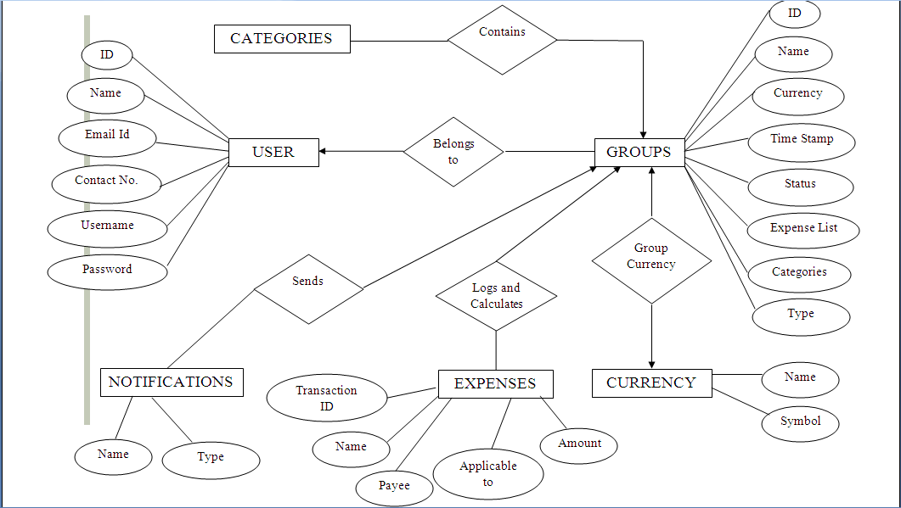
Figure 3.1 Entity Relationship Diagram

  - Use-Case Diagram

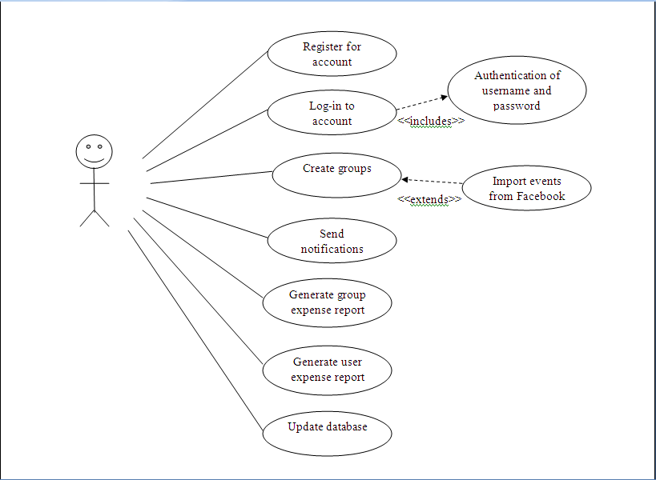
Figure 3.2 Use-Case Diagram

  - Class Diagram
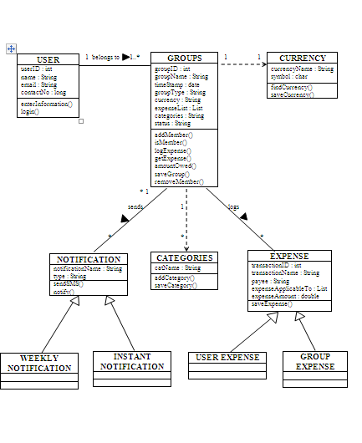Figure 3.3 Class Diagram
  - Activity Diagram
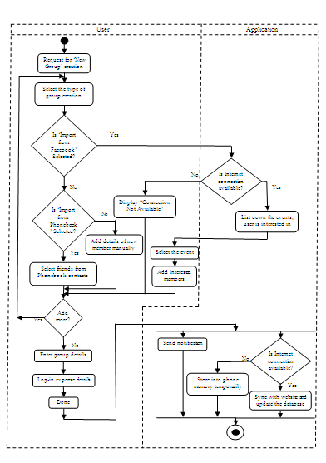
Figure 3.4 Activity Diagram
3.5 Deployment Diagram
3G
GPRS

User Workstation
googleChrome.exe
<<device>>
Mobile Handset

Web Server

groupExpenser.jar

Database Server
user.db
groupInformation.db
expenseDetails.db
reports.db

Application Server
login.dll
createGroup.exe
logExpense.exe
sendNotification.exe
createReport.exe

Backup Server

CONCLUSION

In this report we have discussed a flexible solution for keeping track of group expenses on the go rather than the contemporary way of making mental and sometimes erroneous calculations. We discussed at length about some existing applications along with their limitation. Our applications deals with developing an application to overcome the shortcomings of the existing expense-tracking applications.
We have also made a comparative study of various available technologies to solve and their feasibilities and advantages/disadvantages. Finally we concluded that the best approach would be an Android mobile application synchronized with a web-application to track the expenses. This report discusses the proposed system in detail, with regards to its functionality, strengths and weaknesses.

APPENDIX: REFERENCES

Android
- www.android.com
- www.googlehandsetalliance.com

SQLite
- www.souptonuts.sourceforge.net
- www.sqlitebrowser.sourceforge.net

MySQL
- www.dev.mysql.com
- www.mysql.com

Ruby on Rails
- www.rubyonrails.com
- www.guides.rubyonrails.org
- www.tutorized.com

ASP.NET
- www.startvbdotnet.com
- www.aspnet.com
MS Access
- www.en.wiki.org
- www.allenbrowne.com

